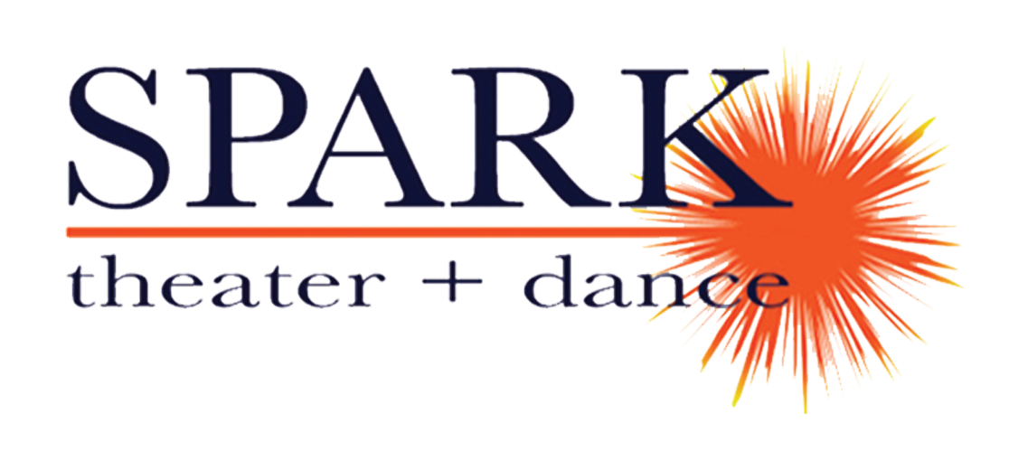
FOR IMMEDIATE RELEASE
April 11, 2019

For more information contact: Joy Donley, publicist, 952/454-7344, joy@sparktheater.com
Publicity photo and MRAC logo graphics* available at www.sparktheater.com

SPARK theater + dance PRESENTS:
A PLAYFUL AND FREE CHILDREN’S THEATER WORKSHOP
at Brooklyn Park’s Community Activity Center
Wednesday, June 19

(Minneapolis/St Paul) – SPARK theater + dance, led by artistic directors Betsy and Corey Mills, will be offering a free workshop of games and creative movement designed as an ideal introduction to the theater for families with children. The 45-minute workshop is for kids ages 5-8 and their caregivers, and all that is needed is a playful spirit and a big imagination!

The workshop will take place on Wednesday, June 19, 2019, from 6:45 – 7:30pm at the Community Activity Center, Grand Room 3, 5600 85th Ave N in Brooklyn Park. Admission is free and registration can be made in person at the front desk, by phone at 763/493-8333 or by going online at www.brooklynpark.org/registration under Activity #812029-01. The Community Activity Center is ADA accessible. Metro Transit routes include 723, 722 and 760 Express.

Betsy Mills is the Co-founder/Artistic Director of SPARK theater + dance. As a teaching artist Betsy has lead multiple classes, workshops and residencies with organizations such as: Zenon Dance School, Inverted Arts (Hope Academy, Mary’s Place and Sojourner Truth Academy), Homeward Bound Theater, Brooklyn Center IB/World Arts School, Waite Park Community School and was a long call substitute dance teacher at Roosevelt High School in Minneapolis. She has also taught classes, residencies, and workshops in California, Washington State, and Wisconsin with SPARK.

Corey Mills is the Co- Founder/Artistic Director of SPARK theater + dance. As a teaching artist, Corey has worked for CLIMB Theater Company, Illusion Theater, The Brave New Workshop, and Inverted Arts as well as teaching multiple classes, residencies, and workshops with SPARK in Minnesota, California, Washington, and Wisconsin. Corey is also adjunct faculty in the theatre department at University of Northwestern St. Paul.

SPARK theater + dance’s mission is to create and perform theater and dance,
to notice and nurture gifts within individuals, and to be a community.

*This activity is made possible by the voters of Minnesota through a grant from the Metropolitan Regional Arts Council, thanks to a legislative appropriation from the arts and cultural heritage fund.





