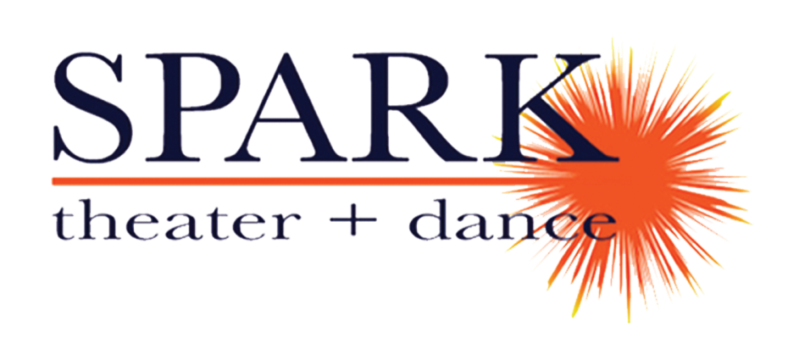
FOR IMMEDIATE RELEASE
April 17, 2019

For more information contact: Joy Donley, publicist, 952/454-7344, joy@sparktheater.com
Publicity photo and MRAC logo graphics* available at www.sparktheater.com

SPARK theater + dance and the City of Brooklyn Park Recreation and Parks Department PRESENT:
THE SUPERCILIOUS WAYS OF WALTER WADING
Written by Corey Mills
Directed by Betsy Mills

Performed at North Hennepin Community College Fine Arts Center Theater
on Saturday, June 22

(Minneapolis/St Paul) – Everyone will be able to afford the admission price to SPARK theater + dance’s latest production—one simply has to bring a playful spirit and a big imagination. SPARK theater + dance, led by artistic directors Betsy and Corey Mills, will be offering a free children’s show designed as an ideal introduction to the theater for families with children ages 3-8 and up. The Supercilious Ways of Walter Wading, a 40-minute physical comedy, features the crazy antics of three woodland sprites as they bounce with yoga balls and defy gravity while trying to convince their stoic friend Walter to come and play.

The Supercilious Ways of Walter Wading show will take place at 10:30am on Saturday, June 22, 2019 at North Hennepin Community College Fine Arts Center Theater, 7411 85th Ave N in Brooklyn Park. Admission is free, and the venue is ADA accessible. Metro Transit routes include 723 and 724.

The cast of The Supercilious Ways of Walter Wading features Corey Mills (SPARK: Home, The Evolution of Sam, Masterminds) as Jean, Joann Oudekerk (SPARK: Home) as Madge, Haley Haupt (SPARK: debut) as Inea and Peyton Dixon (SPARK: debut) as Walter Wading.
The creative team includes Betsy Mills (director/choreographer), Jeremiah Thiessen (stage manager), Corey Mills and Nathan Farley (scenic design) and features music created by Clay Hilman and Jason Harms as well as music provided by www.freeplaymusic.com.
Betsy Mills is the Co-founder/Artistic Director of SPARK theater + dance and the director of Walter. Betsy has a BFA in Dance from the University of Minnesota. She has taught classes and residencies, choreographed and performed locally and regionally for the past 20 years. As a choreographer, her work has been seen with Theater for the Thirsty, Bucket Brigade, Open Window Theater, Homeward Bound Theater, and SPARK; along with Edina Middle School and Plymouth Middle School (5 years).
As a teaching artist Betsy has lead multiple classes, workshops and residencies with organizations such as: Zenon Dance School, Inverted Arts (Hope Academy, Mary’s Place and Sojourner Truth Academy), Homeward Bound Theater, YWAM Montana, Sanctuary CDC (with youth from Nelle Stone Johnson School), Brooklyn Center IB/World Arts School, Waite Park Community School, Jefferson Community School, Menlo Park Alternative High School, Delano Middle and High Schools, Anwatin Middle School, and was a long call substitute dance teacher at Roosevelt High School in Minneapolis. She has also taught classes, residencies, and workshops in California, Washington State, and Wisconsin with SPARK.
Corey Mills is the Co- Founder/Artistic Director of SPARK theater + dance as well as the playwright of Walter. He holds a BA in theatre from St. Cloud State University. Corey has been creating and performing theater in the Twin Cities metro area for the past 20 years. As an actor he has appeared with SPARK, Yellow Tree Theatre, Open Window Theater, Theater for the Thirsty, Theater L’Homme Dieu, The Guthrie Theater, and others. He has written and produced four original plays and was commissioned for two others. He was also a company member of JAZZDANCE! by Danny Buraczeski for four years.
As a teaching artist, Corey has worked for CLIMB Theater Company, Illusion Theater, The Brave New Workshop, and Inverted Arts as well as teaching multiple classes, residencies, and workshops with SPARK in Minnesota, California, Washington, and Wisconsin. Corey is also adjunct faculty in the theatre department at University of Northwestern St. Paul.
SPARK theater + dance’s mission is to create and perform theater and dance,
to notice and nurture gifts within individuals, and to be a community.

*This activity is made possible by the voters of Minnesota through a grant from the Metropolitan Regional Arts Council, thanks to a legislative appropriation from the arts and cultural heritage fund.





